Project Design Phase
Solution Architecture

Date | 12 July 2026
Team ID
Project Name | Ucab-Cab Booking
Maximum Marks | 4 Marks

Solution Architecture:
Solution architecture is a complex process – with many sub-processes – that bridges the gap between business problems and technology solutions. Its goals are to:
- Find the best tech solution to solve existing business problems.
- Describe the structure, characteristics, behavior, and other aspects of the software to project stakeholders.
- Define features, development phases, and solution requirements.
- Provide specifications according to which the solution is defined, managed, and delivered.

Example - Solution Architecture Diagram:


Figure 1: Architecture and data flow of the voice patient diary sample application
Reference: https://aws.amazon.com/blogs/industries/voice-applications-in-clinical-research-powered-by-ai-on-aws-part-1-architecture-and-design-considerations/

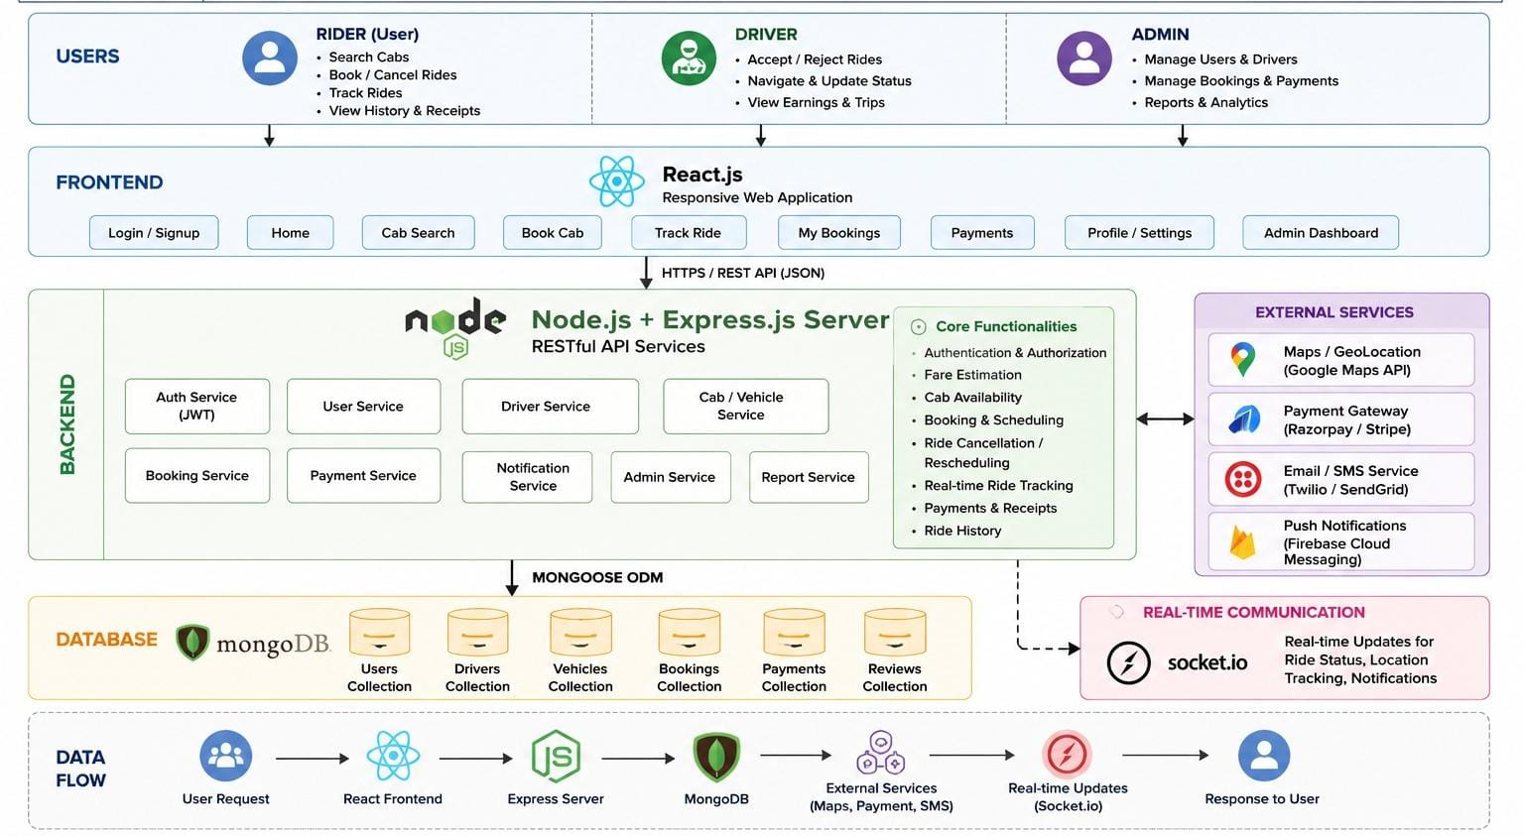
The Ucab – MERN Stack Cab Booking System follows a layered architecture based on the MERN Stack (MongoDB, Express.js, React.js, and Node.js). The system is designed to provide a scalable, secure, and responsive cab booking platform for users, drivers, and administrators.
1. User Layer
The application supports three different user roles:
- Rider (User): Registers, logs in, searches for cabs, books rides, tracks rides, views booking history, downloads receipts, and makes payments.
- Driver: Accepts or rejects ride requests, updates ride status, manages trips, and views earnings.
- Admin: Manages users, drivers, bookings, payments, vehicle categories, and system reports.
2. Frontend Layer (React.js)
The frontend is developed using React.js, providing a responsive and interactive user interface. It includes modules such as Login/Signup, Home, Cab Search, Book Cab, Ride Tracking, My Bookings, Payments, Profile Management, and the Admin Dashboard. The frontend communicates with the backend through REST APIs using Axios.
3. Backend Layer (Node.js & Express.js)
The backend is built using Node.js and Express.js, exposing RESTful APIs that handle business logic and user requests. It includes services for:
- Authentication & Authorization (JWT)
- User Management
- Driver Management
- Cab & Vehicle Management
- Booking Management
- Payment Processing
- Notifications
- Report Generation
4. External Services
The application integrates external services to enhance functionality:
- Google Maps API for location and route services.
- Payment Gateway (Razorpay/Stripe) for secure online payments.
- Email/SMS Services for booking confirmations and notifications.
- Firebase Cloud Messaging for push notifications.
5. Database Layer (MongoDB)
MongoDB stores all application data using Mongoose ODM. The primary collections include:
- Users
- Drivers
- Vehicles
- Bookings
- Payments
- Reviews
6. Real-Time Communication
The application uses Socket.IO to provide real-time ride updates, including driver location tracking, ride status changes, and instant notifications.
7. Data Flow
- The user interacts with the React frontend.
- The frontend sends API requests to the Express.js server.
- The backend validates requests using JWT authentication.
- Business logic processes booking, payment, and ride management.
- MongoDB stores and retrieves application data.
- External APIs handle maps, payments, and notifications.
- Socket.IO delivers real-time ride updates.
- The processed response is returned to the frontend and displayed to the user.

